**PharmaCare**

**Software Installation Plan**

**Date | 25 – 11 – 18**

**PharmaCare Development Team**

# Table of contents

Contents

Table of contents 2

Introduction - Jakob 3

Objectives - Jake 3

Installation Method - Jake 3

Checklist – Server System Requirements - Ruan 4

Checklist – Client System Requirements - Dion 5

Checklist – Security and Organisational Requirements - Jakob 6

Checklist – Pre-Installation Tasks and Resource Requirements - Rani 6

Data Requirements - Brayden 7

Installation Procedure – Application and Database 8

**Application Web Server Deployment – Jakob** 8

**Application Installation (Setup File) - Jakob** 11

**Database Installation - Brayden** 13

**Post-Installation Tasks** 13

Uninstallation Procedure - Jakob 14

Sign-Off - Everyone 16

# Introduction - Jakob

The RightCare hospital is currently looking for an upgrade to its systems and operations to allow the staff to have an easier and more efficient work experience. Currently, multiple staff members are experiencing different Information Technology issues which they would like addressed. PharmaCare which is the new planned system and was proposed by Jack Smith, Director of systems development at RightCare Hospital and will be a “three-tier” system. The purpose of the new program is to reduce workload and increase efficiency for doctors, staff, and pharmacists to complete their work and help patents. This will be done by creating an easy to use website UI which enables all staff to browse, update, and create new prescriptions, drugs, and room information for patients. In order to develop a system like this a software installation plan will be needed in order to run operations smoothly and get a better understanding for what is required. As for version information for the program we initially will start with version 0.1 and work our way up to version 1.0 or final release. After that we will increment the update versions by 0.1 for future patches and bug fixes. This document will detail the objectives, methods, requirements, and procedures for the software installation.

# Objectives - Jake

The objective is to upgrade the RightCare Hospital systems, this is accomplished by resolving major issues with the current technology as well as making quality of life changes in the workplace. The expected outcome of these changes will be to improve the overall functionality of the hospital by increasing productivity of the staff while simultaneously decreasing workload.

# Installation Method - Jake

The system will be installed using a single exe because it does not have a great deal of components. This negates the need for a installation package and is a simple and clean method. The system will have to be installed throughout the entire hospital, due to this fact the installation will be unattended meaning no users are not required during the installation process, instead answer files will be used to meet the needs of the installation.

.

# Checklist – Server System Requirements - Ruan

Due to the lack of information about the amount of users assumptions have been made to fill in the void. It was presumed that at least ~500 people will come in and out of the hospital on the daily, as well as ~60 doctors.

Minimal Requirements:

Hard drive: BarraCuda SSD 500 GB

Processor: AMD Athlon X2 7550 / Intel® Core™ i5-3210M

Ram: 20 GB

Recommended Requirements:

Hard drive: BarraCuda SSD 1 TB

Processor: AMD Ryzen™ 7 2700X / Intel® Core™ i9-9900K

Ram: 32 GB

Licensing and Software:

MySQL Database Management Software - GNU General Public License version 2

Ubuntu Server - GNU General Public License

Framework .NET 4.6 - The MIT License

# Checklist – Client System Requirements - Dion

Minimum:

CPU: Intel Pentium G630T / Intel Core i3-370M / AMD Phenom II N950   Quad-Core / AMD Athlon II X2 280

RAM: 2GB

Storage Type: HDD

Storage Space for Application: 150MB

Total Storage: 50GB

Operating System: Windows 7

Other Software: Microsoft.net Framework

Recommended:

CPU: Intel Core i5-3210M / AMD a10 8700p / AMD Ryzen 3 1200

RAM: 4GB

Storage Type: HDD

Storage Space for Application: 300MB

Total Storage: 100GB

Operating System: Windows 7, 10

Other Software: Microsoft.net Framework

Software - including licence requirements e.g. operating system, database management system (Windows 7 or higher, Microsoft.net framework)

Peripherals:

* Keyboard: **Recommended** Logitech K120 OR any QWERTY keyboard which supports numpad and windows.
* Mouse: wired or wireless mouse
* Screen: 16:9 aspect ratio monitor
* Printer and Scanner: **Recommended** Fuji Xerox CM405df
* Modem: D-Link DIR-878 Gigabit Modem Router

Laptops:

* CPU: 2.0Ghz
* RAM: 8GB+
* Storage: 250GB+
* Anti-Virus software

Mobile Phones:

* Android Marshmallow or Oreo
* IOS 12

Computer Tablets:

* Require Windows OS

# Checklist – Security and Organisational Requirements - Jakob

Having security protocols will reduce the organisation's exposure to security breaches, data loss, malware, and ransomware. These protocols will describe the best practices for using these resources such as software and websites in a way that reduces security vulnerabilities.

* No software contained on websites and app stores will be downloaded and installed which have not be verified or are not needed for the development project. This will help reduce workload for the computer and also reduce the risks for malware or viruses to infect the system.
* Bring your own devices are allowed, but no confidential company data is allowed on that device if it is leaving the office. These devices must also be locked with a passcode and meet hardware requirements.
* All websites and applications in use requiring a password will not be written down and stored within a public environment. All passwords must be stored within an application such as LastPass or secured within a private location.
* Once the application is installed make sure to always remain with the stable release version and not the test, beta, or developer versions of that application. This will ensure a secure and stable experience.

# Checklist – Pre-Installation Tasks and Resource Requirements - Rani

Hardware Requirements:

Minimum:

* CPU: Intel Pentium G630T / Intel Core i3-370M / AMD Phenom II N950      Quad-Core / AMD Athlon II X2 280
* RAM: 2GB
* Storage Type: HDD
* Storage Space for Application: 150MB
* Total Storage: 50GB

Recommended:

* CPU: Intel Pentium G630T / Intel Core i3-370M / AMD Phenom II N950      Quad-Core / AMD Athlon II X2 280
* RAM: 2GB
* Storage Type: HDD
* Storage Space for Application: 150MB
* Total Storage: 50GB

Input Devices: Keyboard, Mouse

Output Devices: Monitors

Software Requirements: Visual Studio, .net Framework, Windows 7(or) 8, Web platform installer, MSSql server, Database, IIS7 enabled.

After installing IIS, run IIS Manager to make sure that .NET Framework version 4 is assigned to the default application pool.

1. Press Windows + R to open the Run dialogue box.

2. Enter “inetmgr”, and then click OK.

3. In the Connections pane, expand the server node and select Application Pools. In the Application Pools pane, DefaultAppPool will be assigned to the .NET framework version 4, if not open a command prompt window and Run as Administrator. Then run aspnet regiis.exe to install ASP.NET 4 in IIS, using some commands.

4. If you closed IIS Manager, run it again, expand the server node, and click Application Pools to display the Application pools pane again.

8. In the Application Pools pane, click DefaultAppPool, and then in the Actions pane click Basic Settings.

9. In the Edit Application Pool dialogue box, change .NET Framework version to .NET Framework V4.0.30319 and click OK. IIS is now ready for you to publish a web application to it, but before you can do that you have to create the databases that you will use in the test environment.

10. Install SQL Server Express LocalDB will not work in IIS, so for the test environment, you need to have SQL Server Express.

11. Create SQL Server Express databases for the test environment.12. Create a grant script for the new database.

12. Run the grant script in the application database.

13. Publish to  IIS: The deployment package consists of a zip file that contains all the files and metadata to install a site in IIS.

Folder permissions and server permissions like read-only, write-only and whole are to be assigned.

# Data Requirements - Brayden

The PharmaCare database tables do not require any pre-populated default values as there are no pre-set values defined for the column types due to being no records that share the same or similar values. The application will not require any migration of data from a previous database as it will not be using an old database and will be created from scratch, therefore no data migration plan needs to be used towards the application. Data requirements include using different names and numbers for the database tables. This will ensure that we do not miss possible bugs within our system which might only occur with numbers or letters. We will also use duplicate names, dates, or drug IDs for tables so we can verify there is not errors related to tables having the same names or ID’s.

# Installation Procedure – Application and Database

## **Application Web Server Deployment – Jakob**

**Step 1.**

Once you are ready to deploy your application to a web server you can proceed to the Publish page for your application.

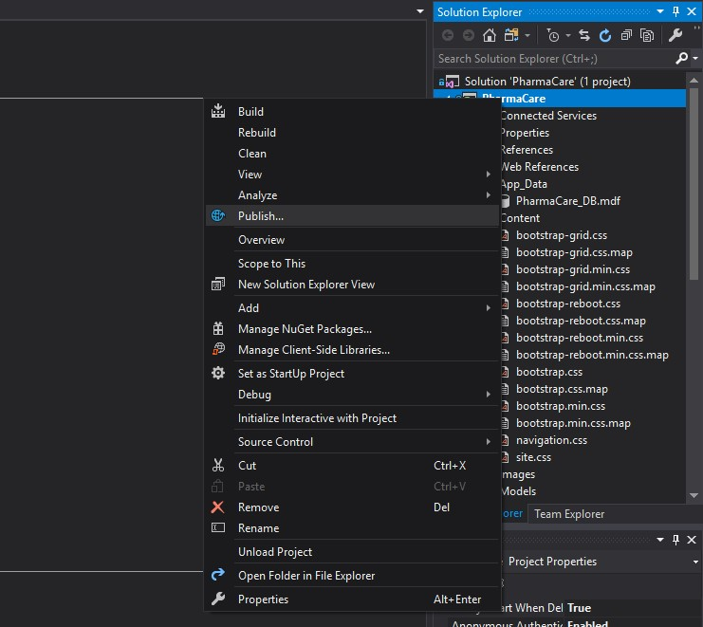

**Step 2.**

You will now see the publish page. From here you can click new profile and select the IIS, FTP, etc. option. Lastly click Publish to go to the next step.

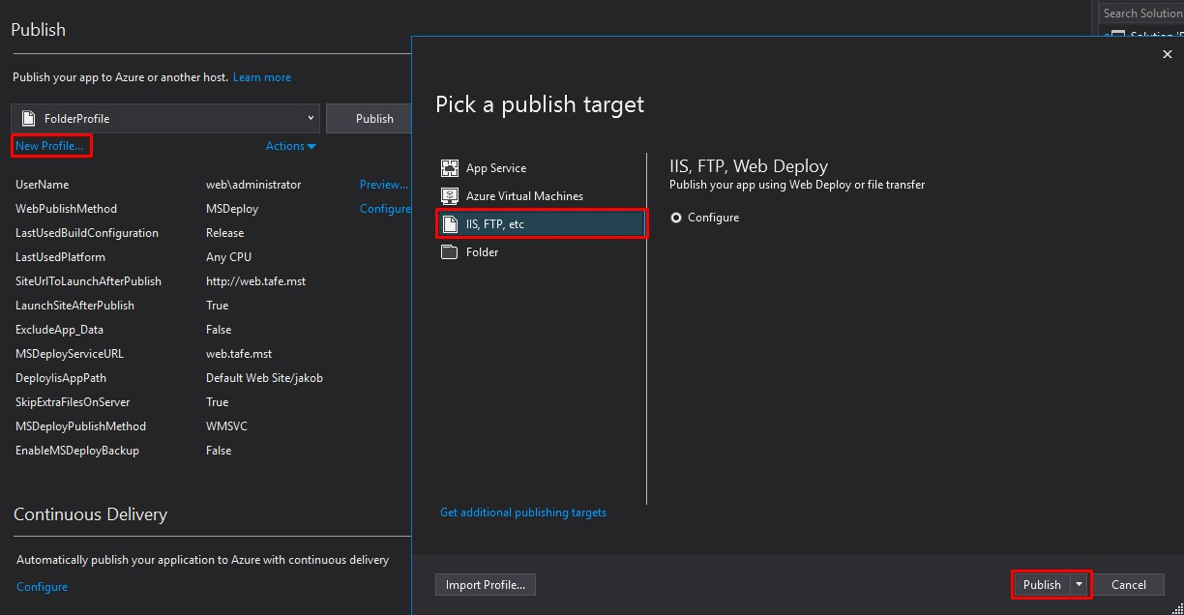

**Step 3.**

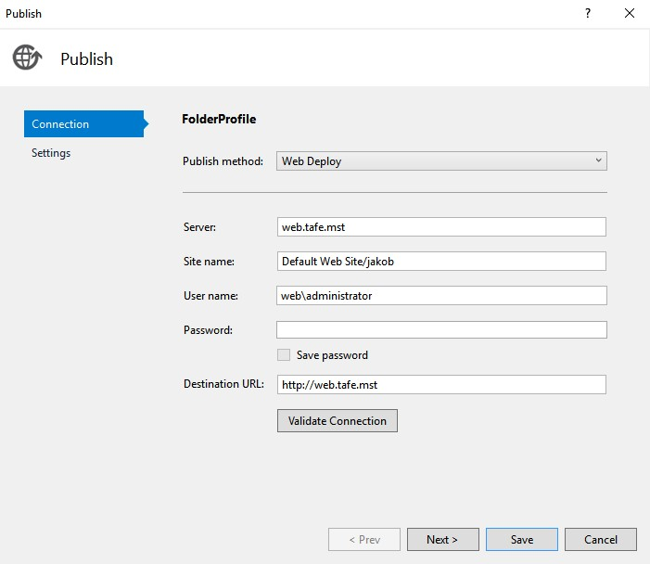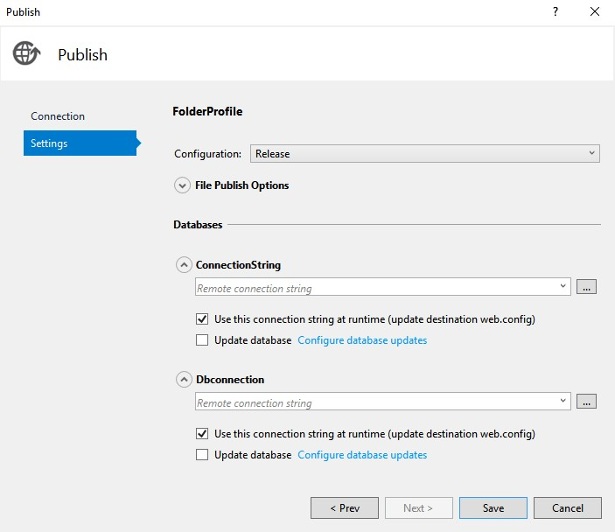The Publish configure menu will now appear allowing you to enter the details necessary for you to set up and connect to the web service. You will want to make sure your publish method is selected as Web deployment and the necessary fields are filled in. After you have filled in the textboxes and set a destination click Validate connection. This will notify you if the connection is successful or has failed. As for the settings page within the publish menu you will want to make sure that release is selected for configuration. Once you have made sure to complete the publish menu requirements click save.

**Step 4.**

You will then return to the Publish main menu. From here you can select publish to begin the deployment of your application to a web server.

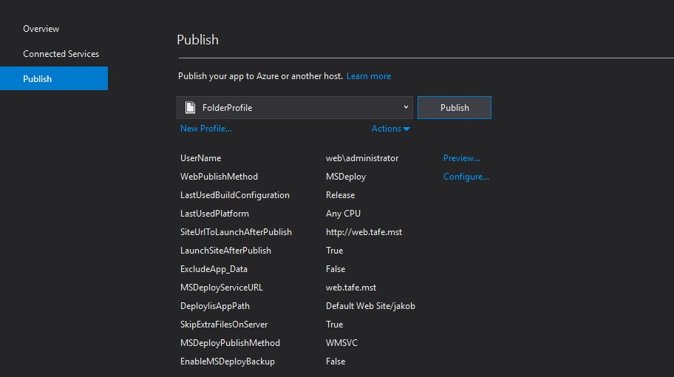

**Step 5.**

You may then see a prompt called the ‘web deploy client’ to enter your username and password which will allow you to connect to the web deploy host.

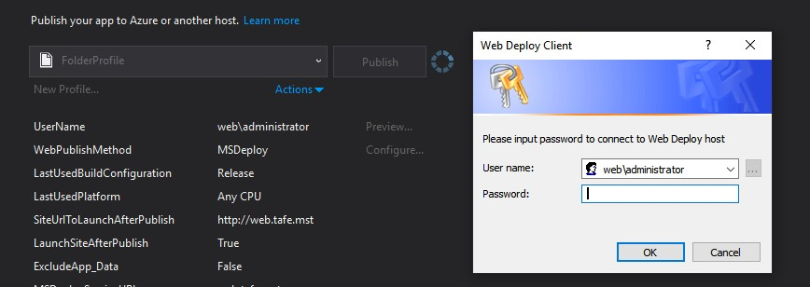

## **Application Installation (Setup File) - Jakob**

**Step 1.**

Locate the installation package called ‘setup.exe’ and double click it to run

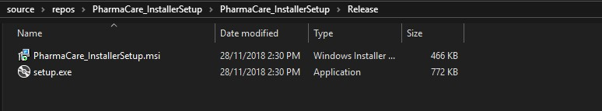

**Step 2.**

This will open the installer wizard. From here you can click next and cancel.

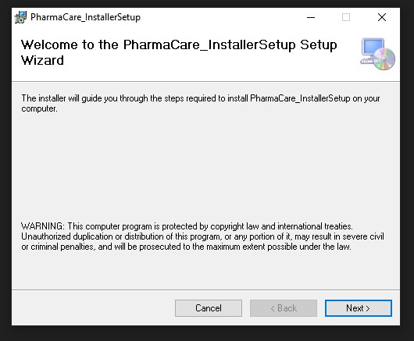

**Step 3.**

Click next and you will be presented with the installation directory screen. From here select the directory you will want the application to be installed.

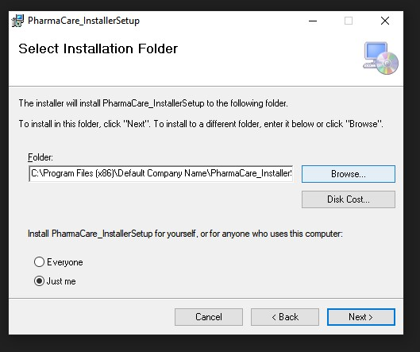

**Step 5.**

You will then be told to confirm the installation by clicking next. This will then show the Installation complete screen which does not require you to do anything else. Simply close that window and enjoy the newly installed application.

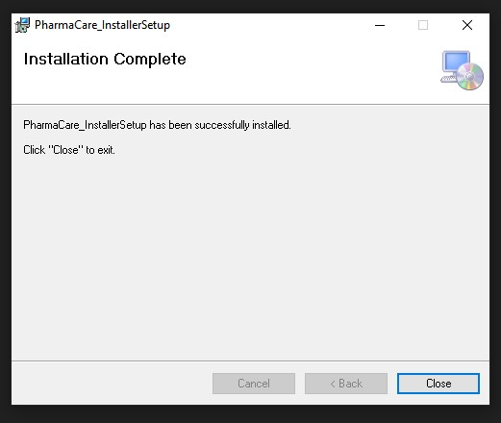

## **Database Installation - Brayden**

### **Post-Installation Tasks**

This section should lists all the tasks required post deployment, which should include:

The configuration of deployment variables or parameters include a connection class that will include SQL connection strings to a data source that will allow for a database to be connected towards the application. This enables the application to obtain database management as it will allow for various queries to be used in specific functionalities of the application. The SQL connection strings will also be used throughout each individual page of the application either through asp.net SqlDataSource or configuration manager which will allow for SQL queries to be executed towards certain functionalities of the application such as displaying data to gridviews or inserting, editing and deleting data within the database.

The configuration of security features of the application such as user roles or permissions is directly related to the PharmaCare database and includes primarily the use of a username and a password in order for a user to acquire access in connecting to the database. The staff table within the database also has a configuration of security features and has four different user roles and permission. These user roles consists of staff, doctors, pharmacist and nurse which all have permissions of individual security levels depending on the role. Each individual role also has usernames and passwords.

The periodic tasks to perform such as backing up components and the database is included through the use of SourceTree and manually backing up files onto a computer system. Backing up components and the database must be performed regularly through SourceTree with each commit that has been pushed towards the repository. This ensures that if any complications were to occur with components or the database, the commit can be rolled back and a previous version can be acquired. The same tasks apply for manually backing up files onto a computer system which ensures that if any merging conflicts occur within SourceTree, a previous version that is working can be committed towards SourceTree to overwrite the current version that has conflicts.

Software updates are crucial and need to be completed and installed successfully before the implementation and connection of the database towards the application. The reason as to why this is crucial is because software updates provide patches towards security holes or any security vulnerabilities that may be present within a database application. These security holes or vulnerabilities can be damaging towards a database as potential data could be leaked or acquired from an unauthorized individual leading to data breaches within the application occurring. The software updates also provide new or enhanced features which improves the stability of the software. Software updates specifically for a database application can be easily installed by downloading the latest version of the software or it will most likely already be automatically updated as majority of software specifically database applications provide automatic updates.

# Uninstallation Procedure - Jakob

**Step 1.**

Open your taskbar search at the bottom left corner of your screen. This will look different with windows 8.0 and 8.1.

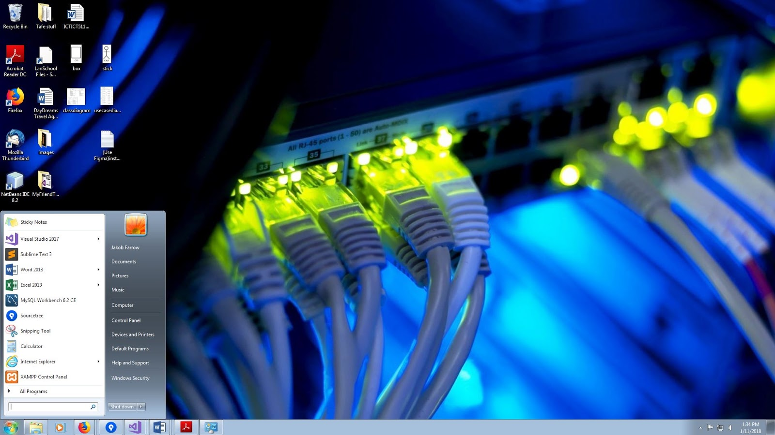

**Step 2.**

Proceed to click Control panel to the right of the taskbar search. You can also use the search bar to search ‘Control panel’ if you don’t see it to the right.

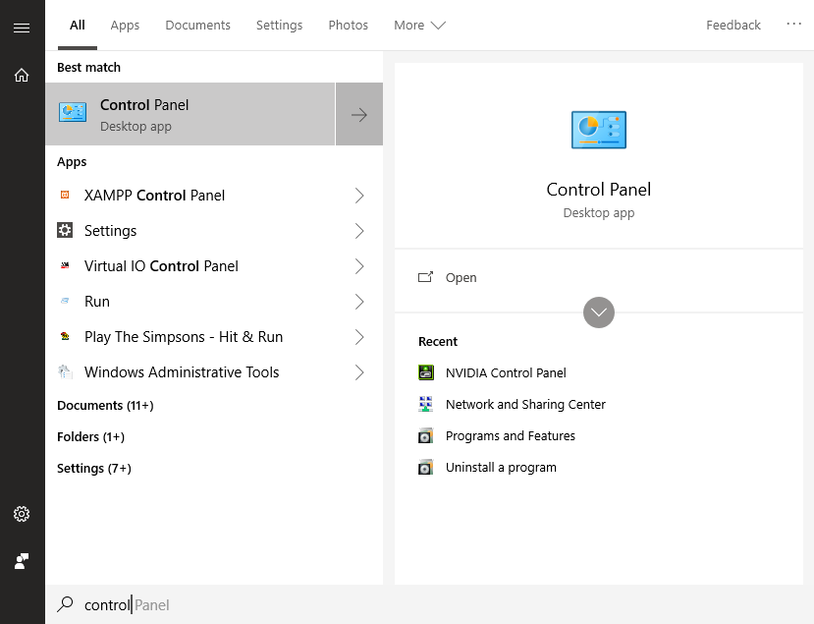

**Step 3.**

You will then see two possible layouts of the control panel. Within ‘View by: Category’ you will see Programs. Click the blue link underneath Programs which say ‘Uninstall a program’.

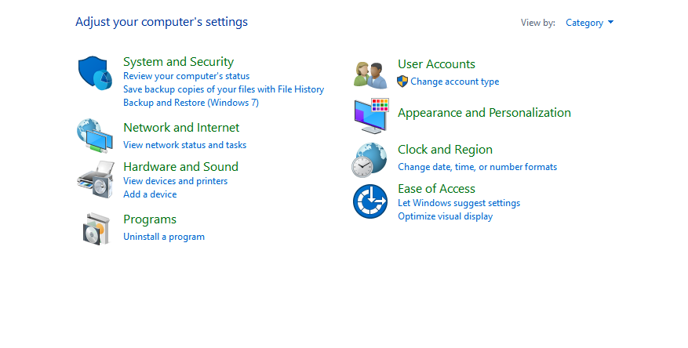

**Step 4.**

Locate the application within the list. Once you have found the application proceed to right click over it and select 'Uninstall’. You may then be asked to verify the uninstallation and how much will want removed. Then wait for the windows installer to prepare and remove the application. Check the application directory and see if there is any remaining files.

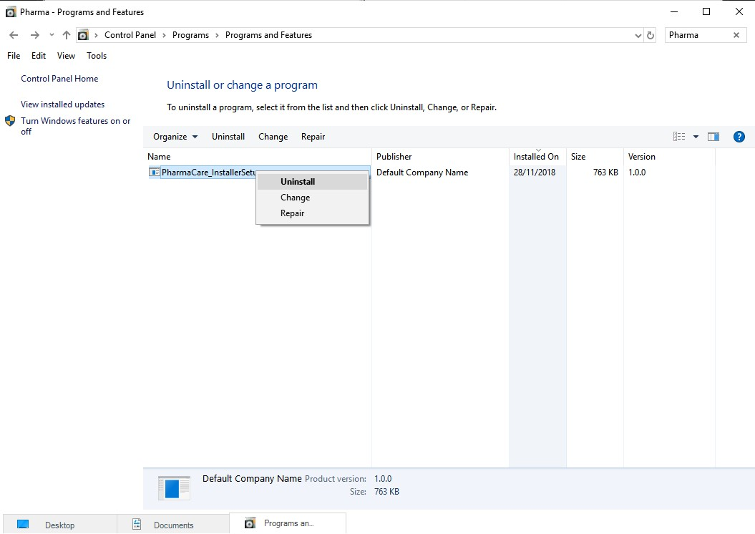

# Sign-Off - Everyone

·                Sign-off sheet where everyone involved in the deployment process will sign

|  |  |  |  |
| --- | --- | --- | --- |
| **Organization Name:** | PharmaCare | **Date:** | 25/11/18 |

|  |  |  |  |
| --- | --- | --- | --- |
| **Name:** | **Date:** |  | **Time Complete** |
| Brayden | 22/11/18 |  | 22/11/18 |
| Dion | 19/11/18 |  | 19/11/18 |
| Jake | 19/11/18 |  | 19/11/18 |
| Jakob | 21/11/18 |  | 21/11/18 |
| Rani | 23/11/18 |  | 23/11/18 |
| Ruan | 23/11/18 |  | 23/11/18 |